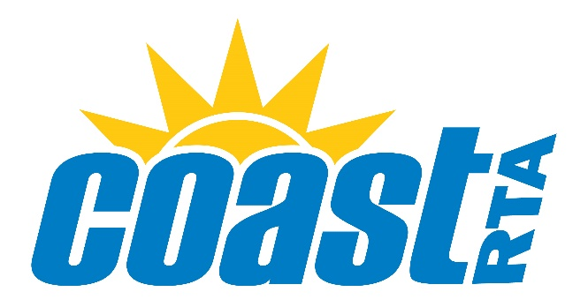
Waccamaw Regional Transportation Authority
Board of Directors Meeting Agenda
May 3, 2023
12:00 PM
DRAFT

- Welcome and Call to Order
- Invocation and Pledge of Allegiance
- Approval of Agenda
- Approval of Minutes – March 12, 2023
- Acknowledgement of Visitors
- Public Comment (3-minute time limit)
- Committee Reports
  - Service/PAC Committee
  - Finance Committee
    - Resolution MAR2023-08 Approval to Implement Service Changes
  - Compensation Committee
  - Other Ad Hoc Committees
- Old Business
- New Business
- General Manager’s Report
- Good of the Order
- Announcements
- Adjournment

Next meeting date: Wednesday, May 31, 2023 @ 12:00PM

