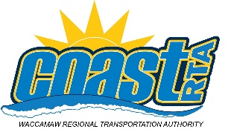
Contact:
Lauren Morris, Public Information Officer
lmorris@coastrta.com
(843) 333-4220 (cell)
(843) 488-6061 (office)
FOR IMMEDIATE RELEASE
February 21, 2021
Public Input Session for Coast RTA Expanded Service in Georgetown County

Conway (SC) – Coast RTA is expanding service in Georgetown County and wants to hear from you during a Facebook Live session on Monday February 22, 2021 at 2pm. To join simply “like” the Coast RTA Facebook page, and join at 2pm.
Currently, Coast RTA provides service to Georgetown County via Route 16 and Route 16 Express. The Route connects both urban and rural parts of the county, along Route 17 and 701.
To access the survey, please visit https://coastrta.com/georgetown-survey/ or it can be accessed on our home page www.RideCoastRTA.com.
For more information including additional route, schedule and fares information, call 843-488-0865 or visit the NEW Coast RTA website www.CoastRTA.com. Become a Coast RTA fan on Facebook or follow us on Twitter @CoastRTA. Coast RTA recommends tracking service in real time by downloading the APP at www.CoastRTARideTracker.com.

###
Coast RTA’s mission is to provide safe, reliable, affordable, clean and courteous mass public transportation that enhances the quality of life for residents and supports the growth of tourism.

